Performance Statistics

➔ Failed Attempts Statistics

Test File | Cuckoo | Open Addressing | Separate Chaining | My Hashing (Quadratic Probing)
sample | 2 | 2 | 2 | 2
in1 | 417256 | 646155 | 467214 | 102712
in2 | 418426 | 639310 | 467074 | 102443
in3 | 418480 | 642916 | 467873 | 102747
in4 | 417296 | 643727 | 467178 | 102451
in5 | 416696 | 641919 | 466202 | 102789
in6 | 417031 | 641644 | 466943 | 102541

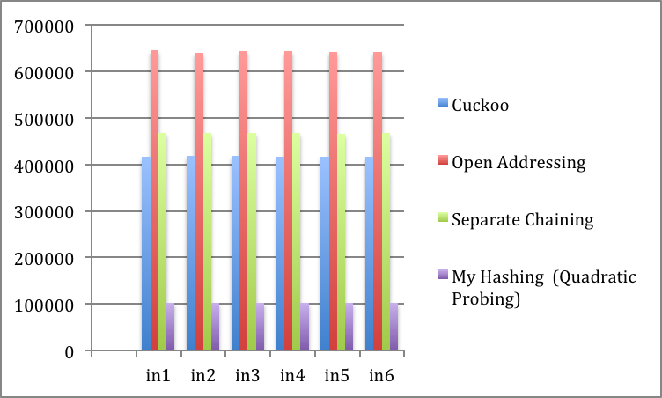

➔ Time Statistics

Test File | Cuckoo | Open Addressing | Separate Chaining | My Hashing (Quadratic Probing)
in1 | 1.938 | 1.267 | 2.115 | 1.495
in2 | 1.907 | 1.311 | 2.088 | 1.887
in3 | 2.003 | 1.324 | 2.074 | 1.466
in4 | 2.556 | 1.334 | 2.059 | 1.46
in5 | 2.205 | 1.329 | 1.999 | 1.45
in6 | 2.469 | 1.296 | 2.012 | 1.459

